TO: Kristian Medri, Professor, Humber College School of Applied Technology

FROM: Nicolas Cristiano, Computer Engineering Technology Student

Cc: Gurwarris Singh Sohi and Shubham Sharma

DATE: February 4th, 2020

SUBJECT: Ping-Pong Machine Application Status

Research has shown that tennis players, both new and experienced, are using tennis ball machines in order to gain experience and develop their abilities in an effective and efficient manner. Capitalizing on this trend, hardware has been developed for a ping-pong machine, which works largely in the same manner as a tennis machine, only on a smaller scale. Software has also been developed for an application that allows the player to adjust various play factors for how the ping-pong machine operates.

**Login Activity**

Upon opening the application, the player is required to input their individual data into a signup page. These fields include:

* First Name
* Last Name
* Email
* Password
* Password Confirmation

There are several parameters that need to be achieved for the user to be able to sign up. Most significantly, none of the fields are allowed to be empty. The first name and last name must not have any numbers or special characters (ie ?,!$). The email and password must not have any spaces in between characters. The password must be eight to sixteen characters, and have at least one lowercase letter, one uppercase letter, one special character and one number. The password confirmation must match up perfectly with the password. After the user signs up, they can login for all subsequent sessions, where they only need to input their email and password.

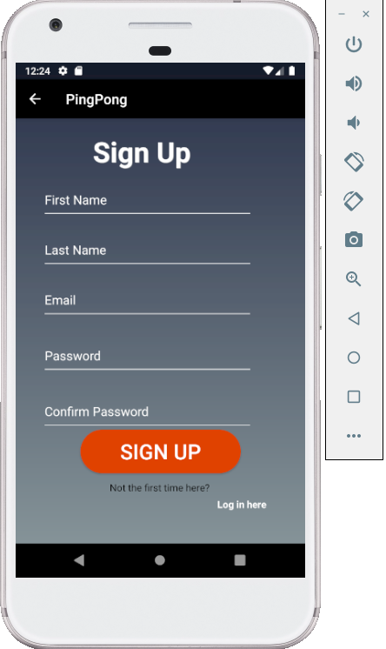

**Figure 1: Sign Up Page**

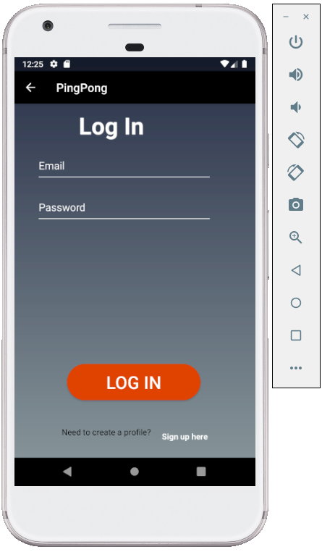

**Figure 2: Login Page**

**Data Visualization Activity**

Once the user logs into the application, they can access a profile page, which displays their first name, last name, email address and a serial number that denotes what machine the given account is linked to. When the user first logs in, the application’s database stores what serial number they have. The profile screen also lets the users access their play settings from the last 30 play sessions.

**Action Control Activity**

Before the user enters their play session, they can select from a range of play settings. These settings include:

* Difficulty: easy, medium and hard difficulties are selectable, which impact both the launch speed, the range of elevations and type or variation of shots the ping pong balls launch at the user
* Angle: the user can control the horizontal launch angle of the ball from a neutral center position to a 25 degree range, both left and right of the center.
* Launch Interval: the user can control the time interval the balls launch between one another. They can choose between 0.3, 1, 2 and 5 seconds.

If the user does not choose any of their individual settings, they are set to default, which consists of an easy difficulty, a 10-degree launch angle, and 5 second launch interval. Once the user chooses their settings, they can launch their play session in another screen. When launched, the application displays a timer that shows the duration of the play session. If the user wants to change their settings, they need to press the stop button so they can re-access the settings page. They are then able to restart the play session once everything is adjusted to their liking.

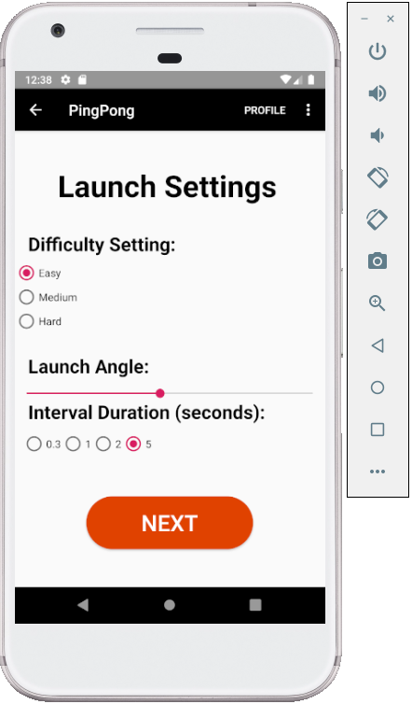

**Figure 3: Launch Settings Page**